0

VOIP lab experiment#11
Creating Announcement

Installation and Repair of Telecommunications Equipment

Name of student:________________
Group Number:_________________
Date:_________________________

The purpose of the lab is to create an announcement.

- Go to announcements.
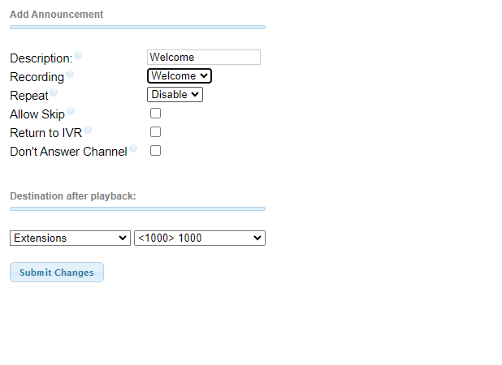
- Insert an description

- Select the recording that you created

- Submit changes and then click on apply config.

- Change you incoming route:
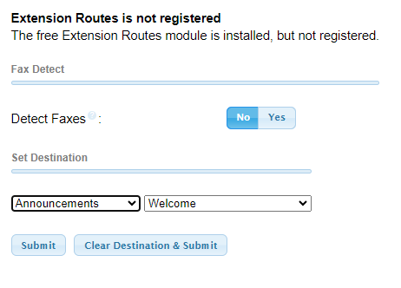

Instead of extension change to announcements and select your announcement.

